**Smart Street Light Proof of Concept**

**Project Plan and Product Specifications**

EEL 4911C

10/9/15

Team #: 9

Faculty Advisors:

Dr. Jerris Hooker

Team Members:

Tucker Russ

Thor Cutler

Brandon Berry

Anthony Giordano

**Table of Contents**

**Abstract3**

1. **Introduction3**
2. **Project Definition3**

2.1 Background Research3

2.2 Need Statement4

2.3 Goal Statement5

1. **Constraints5**
   1. Design Specifications
   2. Performance Specifications
2. **Methodology5**
   1. Schedule
   2. Resource Allocation
3. **Conclusion10**
4. **References10**

**Abstract**

This report is a summary of the specifications the team plans to implement on the Smart Streetlights project. The basic design has been laid out in order to plan and begin building process. A schedule has been written in order to keep the project’s progress on track and to make sure each step is completed in a timely manner. The project’s tasks have been split between the members of the group based on their knowledge and experience. Now that the budget has been set and the parts to be used have been determined, the next step is to design and build the prototypes.

**Introduction**

Current streetlights use outdated bulbs that are more expensive and less dependent than current LED technology. With the system that is in place now, when a house or streetlight loses power, the only way the utility provider knows that a house is without electricity or a streetlight is out is when a customer calls to report an outage. The design being developed for Smart Streetlights will operate as a highly efficient network providing lower energy costs, maintenance costs, and CO2 emissions. The streetlights or household power status will communicate through a wireless Xbee network and connect peer to peer in order for their current statuses to be accessed. A node placed on each street light will communicate wirelessly with a single central station where the information will then be accessible on a user interface.

**Project Definition**

a) Background research

XBee Series 1:

The team will design a model of the Smart Streetlight network using three XBee wireless modules in order for each light to communicate. The XBee was chosen by the team because of it is good for point-to-point, multipoint and convertible to a mesh network. They are able to automatically sync and pass data back and forth, which will allow the user to recognize the status of the power.

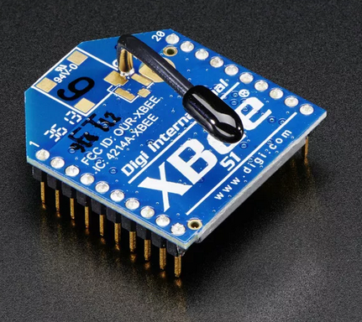

Raspberry Pi 2: The Raspberry Pi 2 is used because of its ability to connect to a LCD and to perform Linux based operations to control the User Interface of the Outage Management and control over the Xbee Devices. The devices can be easily connected to the Pi via a USB controller.

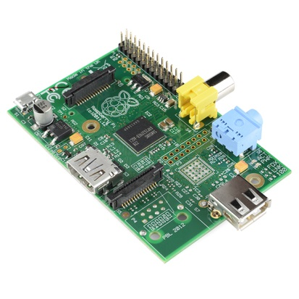

DC Power Supply: A Computer DC Power supply will be used to power all the Xbee devices along with each LED light. The rest of the peripherals will utilize their own power supplies.

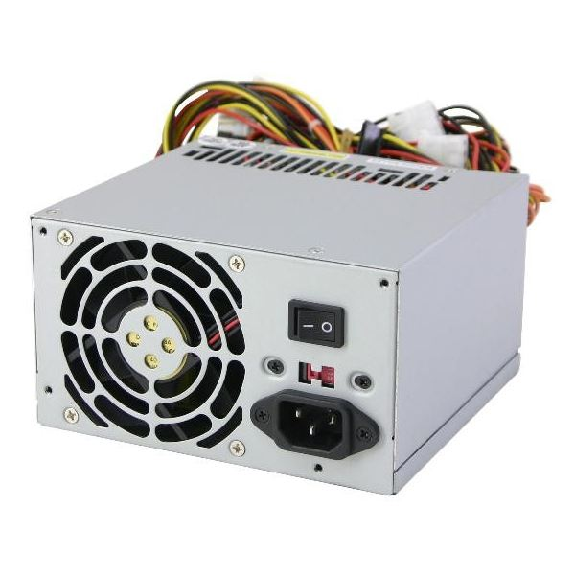

LED Lights: A single 120 LED 3528 will be used on each Streetlight which will provide a 360 degree bulb like light with the advantages of low consumption LEDs.

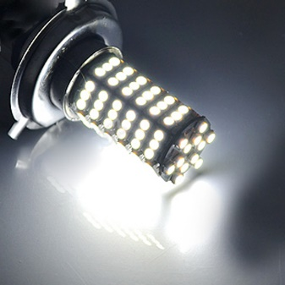

b) **Needs Statement**

In the event that power is lost in a specific household or streetlight the system must be alerted and be able to display the current status. The communication of the power status must be wireless and be able to update user information semi continuously. This communication system is necessary in order for the user to save time and money.

c) **Objectives and Goals**

The team will design a portable small-scale model of the Smart Streetlight system in order to demonstrate its functionality. This will allow the team to easily transport the model around in order for it to be worked on and tested. The model will represent both the household and the streetlight, along with a screen to display the user information.

**Constraints**

|  |  |
| --- | --- |
| Budget | $2,000 |
| Deadline | Mid-Spring |
| Power | DC Power Supply |
| Control | Integrated RaspBerry Pi |
| Display | Portable Cart w/ wheels |
| Goal | Have wireless communications with Streetlights and convert outdated gas fixtures to LED |

a) **Design Specifications**

The mesh network using the three XBees should run as smoothly and efficiently as possible. Each xBee module should be able to update their statuses to a single source continuously in order to stay as up to date as possible. This is important because during a real life, large scale power outage, the utility must act to restore the outage as soon as possible.

b) **Performance Specifications**

The mesh network created by Xbees must have the ability to run 24/7. In addition to this the network must have the functionality to not be limited by a certain number of devices. The number of devices should be almost unlimited as large networks will be created using this technology. There will be some sort of delay in changing status from online to offline and vice versa. This delay should be kept under 1min optimally as the user should know the status change as soon as possible.

**Methodology**

* R1: The SSLS shall alert a user within 10 seconds of a smart-meter or streetlight losing power.
  + Needs Covered: N2, N3
  + Explanation: The purpose of this requirement is to document one of the basic functions of our project. When a street light or smart meter loses power, the system user, by looking at the system’s monitor, will be alerted of the power loss.
* R2: The SSLS shall constantly show the status of all monitored devices, updating every 10 seconds. Status consists of: Needs: Powered on or off, last updated. Wants: voltage, current, power
  + Needs Covered: N4, N5, N9, W1, W3, W4,
  + Explanation: The purpose of this requirement is to ensure that the system will constantly be updating data on a set time interval and not just when a monitored device loses power.
* R3: The SSLS shall receive status signals from monitored devices wirelessly.
  + Needs Covered: N6, N7
  + Explanation: The purpose of this requirement is to simulate that street lights are far enough apart that a wired connection isn’t practical
* R4: The SSLS shall be able to differentiate between different lights by the signal that they send.
  + Needs Covered: N8
  + Explanation: The purpose of this requirement is to ensure that each light sends a slightly different signal as to allow the user to know which light has lost power.
* R5: The SSLS Demo Model shall be built on a cart making it mobile.
  + Needs Covered: N12
  + Explanation: Our whole demo will be built on a cart allowing presentations to be held in multiple locations and making working on the Demo easier.
* R6: The SSLS Demo Model shall have a monitor to display the status of all monitored devices.
  + Needs Covered: N11, W6
  + Explanation: The Demo will have the screen that displays the SSLS information for each light covered in R1 and R2.
* R7: The SSLS Demo Model shall have at least 1 street light and 1 smart meter that can be shut off to represent power loss.
  + Needs Covered: N10
  + Explanation: This part of the model will be used to represent power loss in a light allowing us to display how the system reacts to power loss in a monitored device.
* R8: The SSLS shall save money over time.
  + Needs Covered: N1
  + Explanation: Using LEDs lead to less maintenance and over time will lead to this system being cheaper than what is currently in place. NOT CURRENTLY TESTABLE/BAD REQUIREMENT

**Work Breakdown Structure**

|  |  |  |  |  |  |  |  |
| --- | --- | --- | --- | --- | --- | --- | --- |
| ID | Activity | Description | Deliverables | Duration (days) | People | Resources | Predecessors |
| 1 | **Communication** |  |  |  |  |  |  |
| 1.1.1 | Xbee P2P Connectivity | Complete connection between 2 xbee devices | Circuit schematic  Simulation Verification | 11 | Tucker(1)  Thor(2) | PC  X-CTU  Simulator |  |
| 1.1.2 | Xbee Mesh Connectivity | 2 xbees must be paired in a mesh network | Circuit schematic  Simulation Verification | 22 | Tucker(1)  Thor(2) | PC  X-CTU  Simulator | 1.1.1 |
| 1.2 | **LED Circuits** | Build and test. |  |  |  |  |  |
| 1.2.1 | Power LED’s | Test LED functionality on Power source | Circuit  Schematic  Simulation  Verification | 12 | Brandon (1)  Anthony (2) | Voltage test bench in Lab |  |
| 1.2.1 | Mount LED’s and xbee | Create a fixture to mount the LED and xBee to | Design  Drawing  Built Product | 15 | Brandon (1) | Possible 3D printing  Legos, etc | 1.1.1  1.2.1 |
| 1.3 | **Power Supply** |  |  |  |  |  |  |
| 1.3.1 | Test DC Power supply | Make sure there is enought output voltage connections for the entire system | Test each output must power all xBee and LED devices | 15 | Anthony (1) | Test bench with multimeter | 1.2 |
| 1.4 | **Raspberry Pi** |  |  |  |  |  |  |
| 1.4.1 | xBee connectivity | Connect an Xbee to the Raspberry Pi to bring in data from other Xbee devices | Circuit  Schematic  Simulation  Verification | 11 | Thor (1)  Tucker (2) | Rasp Pi  Xbee  Xbee USB controller  PC  X-CTU | 1.1.1 |
| 1.4.2 | Outage Notification | Show status of a single Xbee on the Rasp Pi | Simulation  Verification | 32 | Thor(1)  Tucker(1)  Brandon (1)  Anthony (1) | Rasp Pi  Xbee  Xbee USB controller  PC  X-CTU | 1.1.1  1.4.1 |
| 1.4.3 | Outage Notification Mesh | Show status of each Xbee on the Rasp Pi | Simulation  Verification | 42 | Thor(1)  Tucker(1)  Brandon (1)  Anthony (1) | Rasp Pi  Xbee  Xbee USB controller  PC  X-CTU | 1.1.1  1.4.1  1.4.2 |

b) **Resource Allocation**

|  |  |  |  |  |
| --- | --- | --- | --- | --- |
| Item | QTY | Description | Price ($) | Total ($) |
| 1 | 4 | Xbee Series 1 | 35 | 140 |
| 2 | 1 | RaspBerry-Pi 2 Ultimate | 90 | 90 |
| 3 | 1 | Utility Cart | 200 | 200 |
| 4 | 1 | Tontec® 7 Inch Monitor | 90 | 90 |
| 5 | 1 | Wireless Keyboard + Mouse | 35 | 35 |
| 6 | 4 | TI INA209 Current/Power Monitor | 15 | 60 |
| 7 | 1 | ColdFusion HB416PVA Power Meter | 170 | 170 |
| 8 | 3 | G4 3.5W 120 LED 3528 SMD lighs | 10 | 30 |
| 9 | 1 | 300 Watt DC Power Supply | 40 | 40 |
| 10 | 1 | Cables/Wires/Ties/Connectors | 125 | 125 |
| 11 | 1 | Real Life Campus Design Supplies | 75 | 75 |
| 12 | 1 | Software | 100 | 100 |
| 13 | 1 | Screws/mounting supplies | 20 | 20 |
| 14 | 3 | Breadboard for lights/Xbee | 5 | 15 |
| 15 | 1 | Velcro Tape | 10 | 10 |
| 16 | 1 | Resistors and Capacitors | 20 | 20 |
|  |  |  | Total Price | 1,220 |

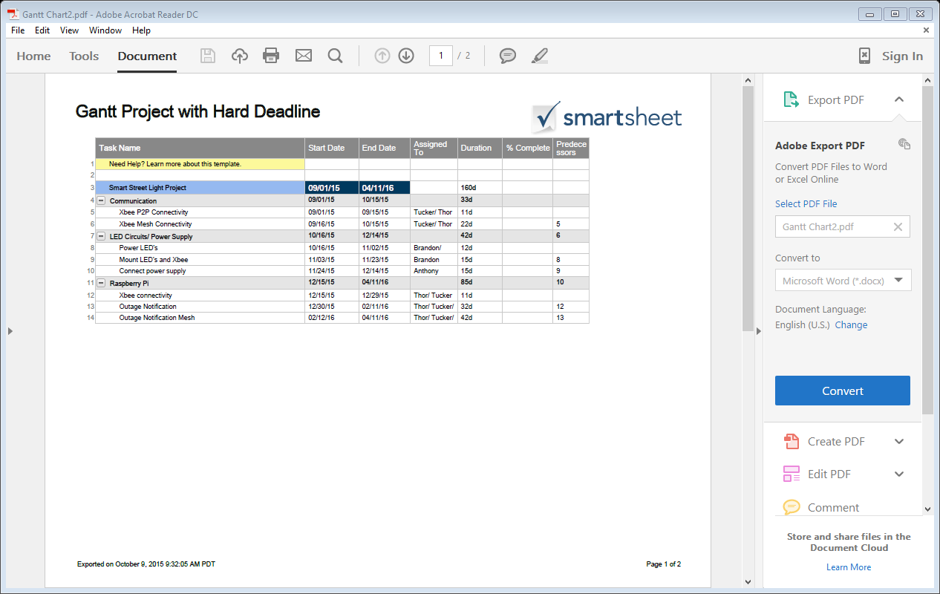

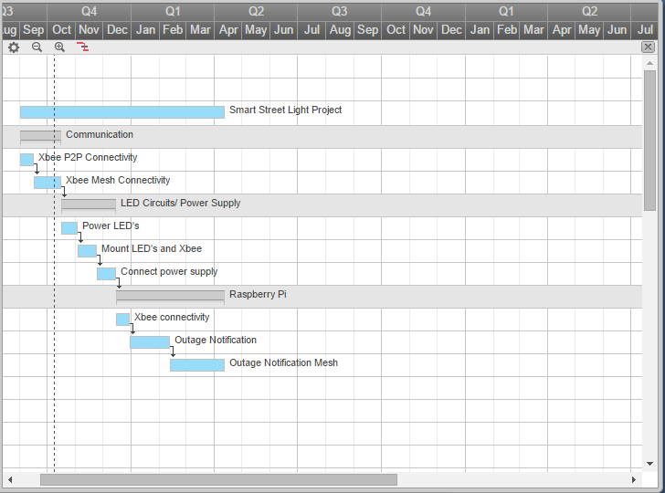

**Conclusion**

The purpose of this report was to review the background information needed to get the Smart Streetlights project up and running. It was important to cover all of the technical specifications in order to plan for the following tasks to be completed. The goal for this project is to build a cost efficient and time saving network to provide data from multiple streetlights to a single source where each lights status can be analyzed by the user. The project will be displayed on a small scale model representing what is meant to be an actual streetlight network.

The next steps for the project have been divided up accordingly between the four team members in the group. They are stated in the methodology section of this report. The following report will be covering the layout of the model to be created and in depth design ideas.

**References**

Tanmay, S., Shue, S., & Conard, J. (2015, April 9). Implementation of Dyamic Source Routing using 802.15.4 on XBee Series 1 Modules. Retrieved October 9, 2015,http://ieeexplore.ieee.org/stamp/stamp.jsp?tp=&arnumber=7132965&isnumber=7132866&tag=1

Urgiles, M., Arpi, P., & Chacon-Troya, D. (2014, August 24). Retrieved from http://ieeexplore.ieee.org/stamp/stamp.jsp?tp=&arnumber=7294165&isnumber=